

data base lab task 04

AITZAZ TAHIR CH 19P0012 SIR MUHAMMAD USMAN



**Task 4.1 Write a query that displays the number of distinct employees in the HOURS**

**table. You should label the column “Number of Employees”.**

select count(distinct(emp_num)) as "Number of Employee" from hours;

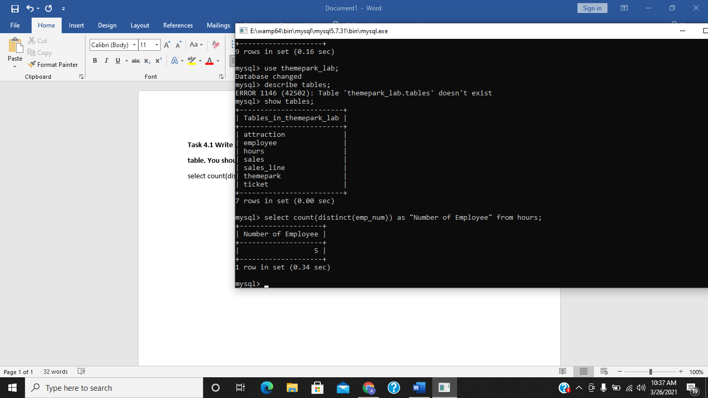

**Task 4.2 Enter the following two queries and examine their output shown in Figure 40.**

SELECT COUNT(*) FROM ATTRACTION;

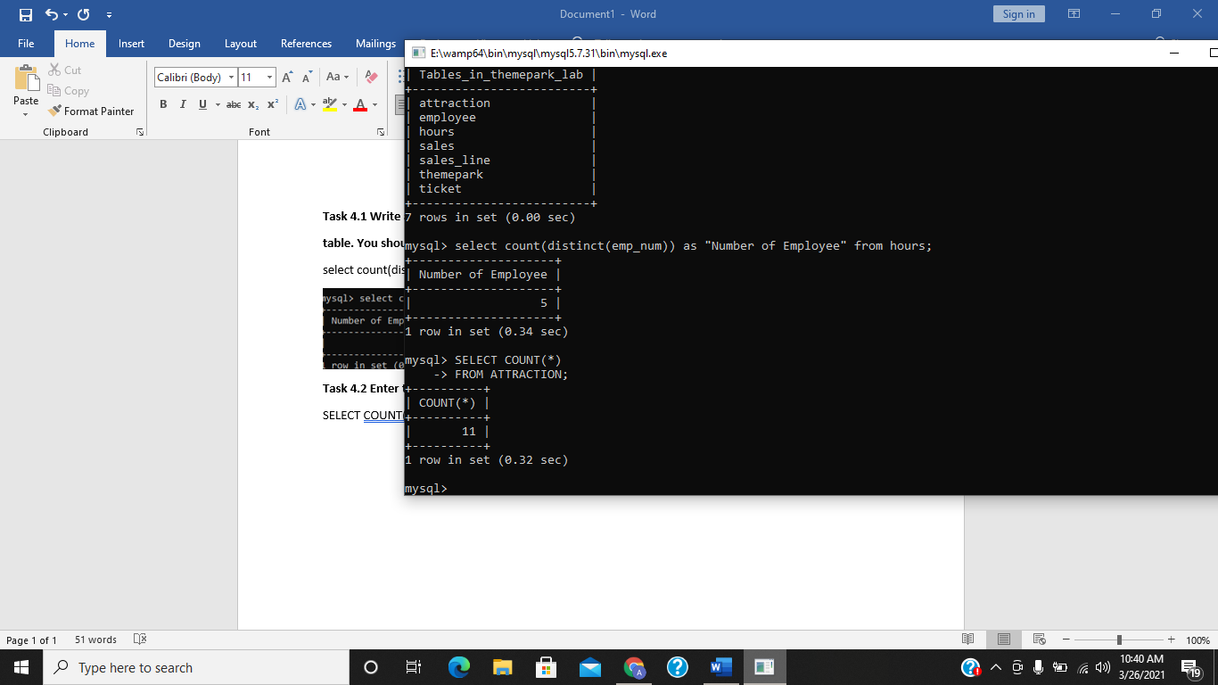

SELECT COUNT(ATTRACT_NAME) FROM ATTRACTION;

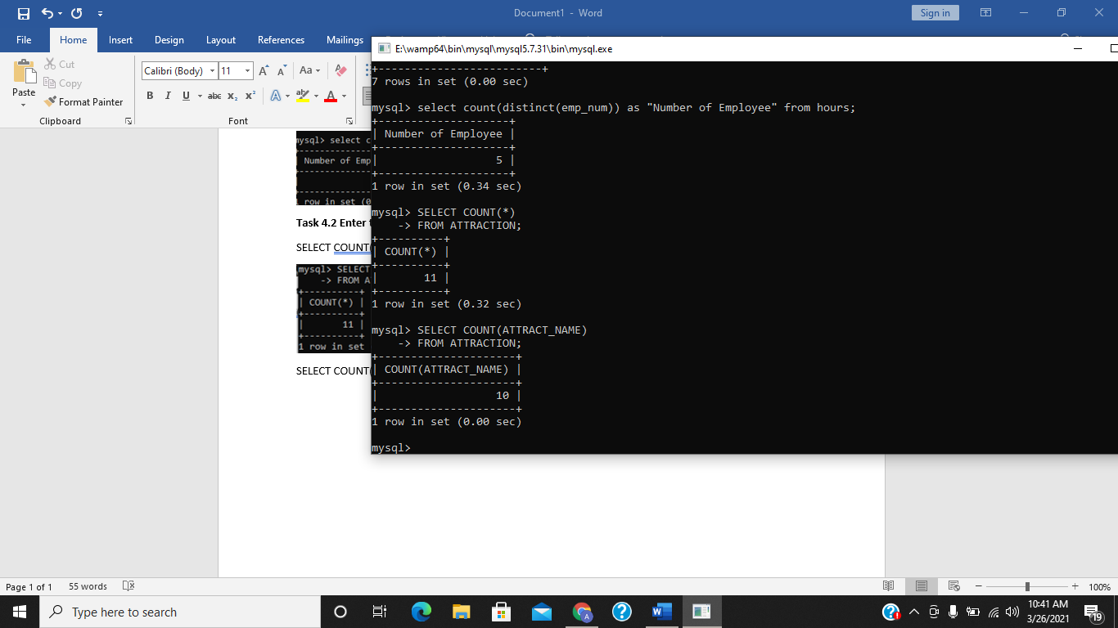

**Can you explain why the number of rows returned is different?**

This is because when we use **“ count ”** using **“ * “** it also counts rows containing **NULL** value.

**Task 4.3 Enter the following query which illustrates the use of the MIN and Max**

**functions.**

SELECT MIN(TICKET_PRICE),max(TICKET_PRICE) FROM TICKET;

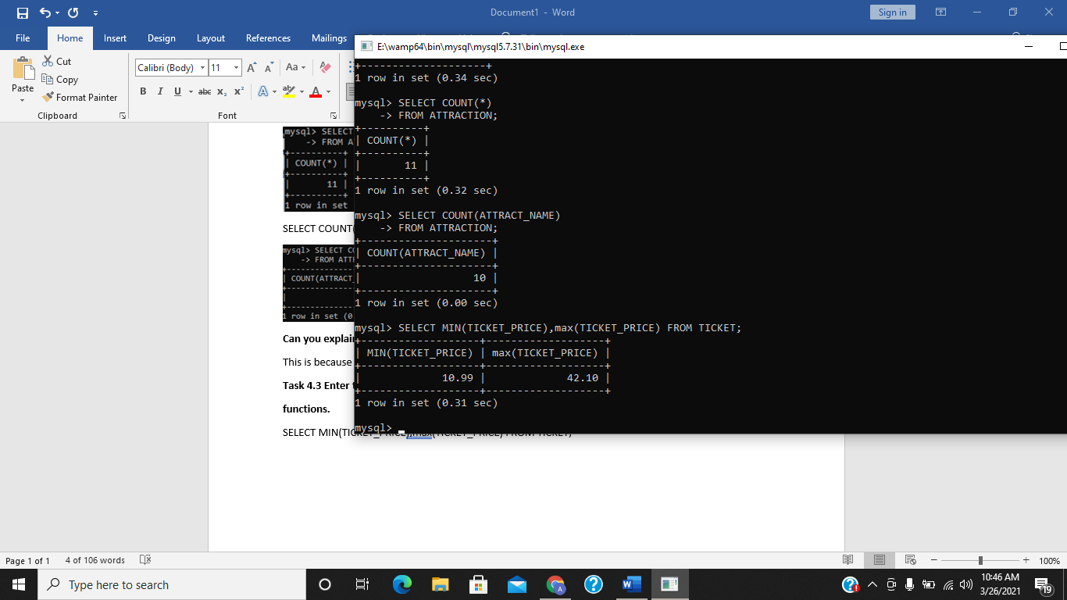

**Task 4.4 Enter the query above and check the results against the output shown in Figure**

**43.**

SELECT PARK_CODE, MIN(TICKET_PRICE),MAX(TICKET_PRICE) FROM TICKET GROUP BY PARK_CODE;

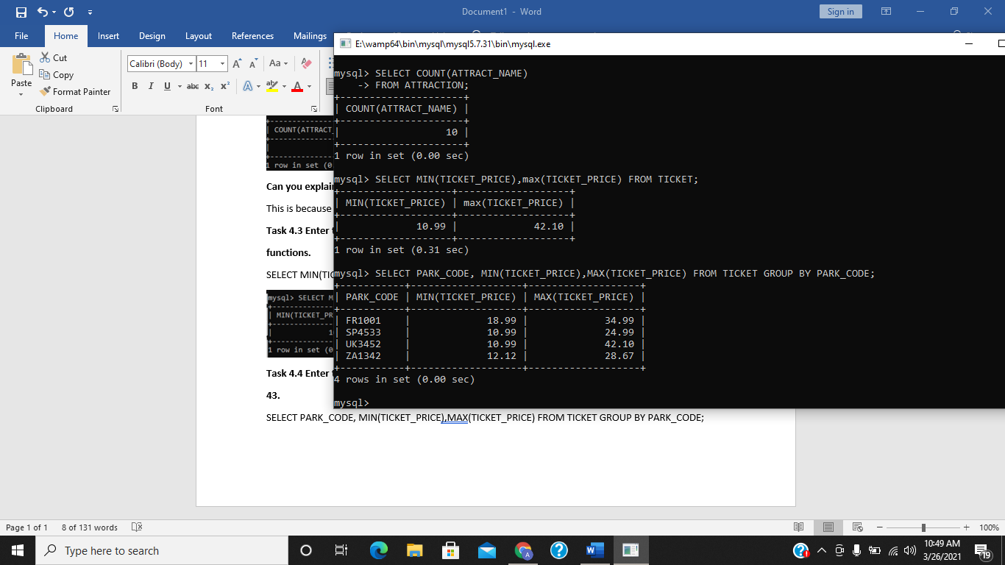

**What happens if you miss out the GROUP BY clause?**

If we miss “ group by “ clause, it will display overall minimum and maximum ticket prices from (whole table **/** all park_code) .

**Task 4.5 Execute the following query and check your results with those shown in Figure**

**47.**

SELECT THEMEPARK.PARK_CODE, PARK_NAME, ATTRACT_NAME, ATTRACT_CAPACITY

FROM THEMEPARK, ATTRACTION

WHERE THEMEPARK.PARK_CODE = ATTRACTION.PARK_CODE;

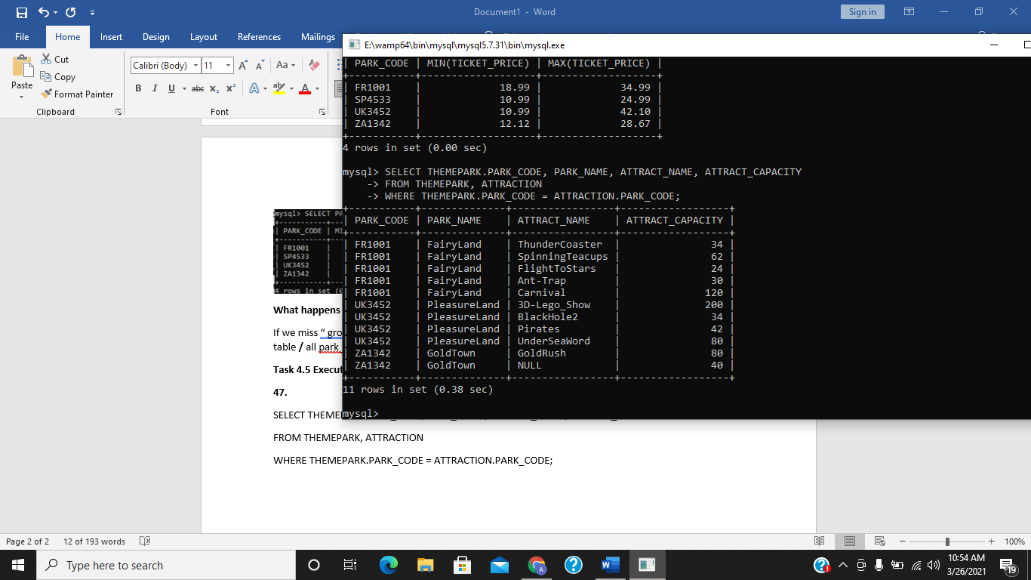

**Then modify the SELECT statement and change THEMEPARK.PARK_CODE to**

**just PARK_CODE. What happens?**

It will give us error as u can see because we didn’t describe the table of coloumn (park_code) because in both tables we have same coloumn(park_code).

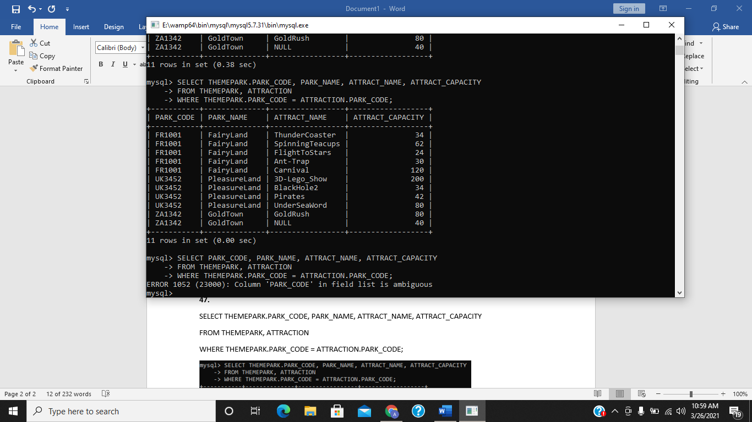

**Task 4.6 Enter the query above and check your results with those shown in Figure 53.**

SELECT THEMEPARK.PARK_CODE, PARK_NAME, ATTRACT_NAME

FROM THEMEPARK LEFT JOIN ATTRACTION ON

THEMEPARK.PARK_CODE = ATTRACTION.PARK_CODE;

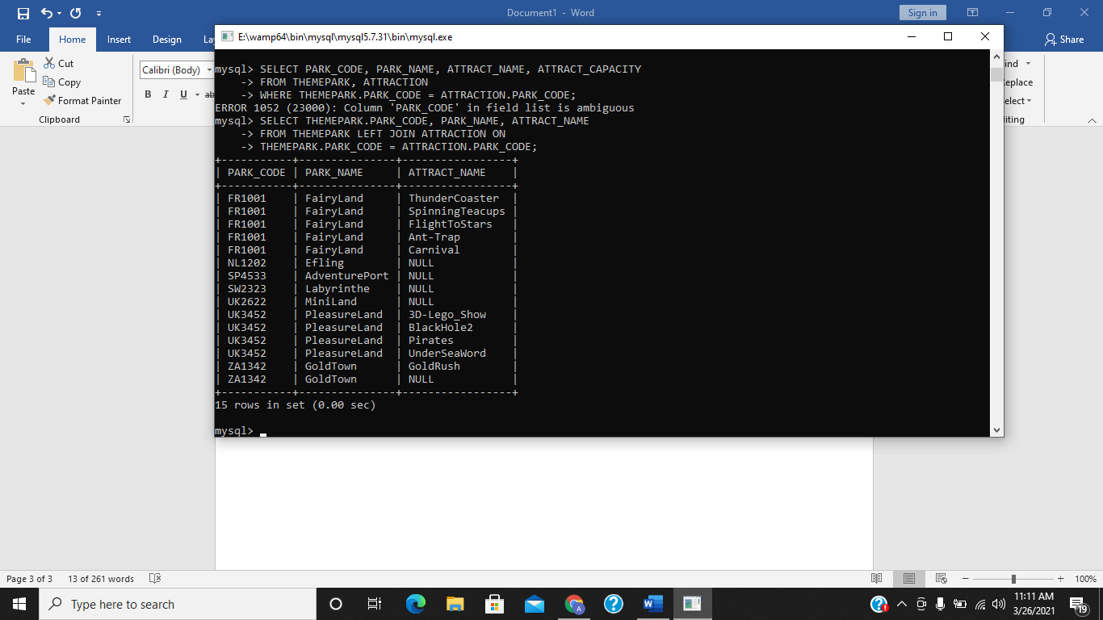

**Task 4.7 Enter the query above and check your results with those shown in Figure 54.**

SELECT THEMEPARK.PARK_CODE, PARK_NAME, ATTRACT_NAME

FROM THEMEPARK RIGHT JOIN ATTRACTION ON

THEMEPARK.PARK_CODE = ATTRACTION.PARK_CODE;

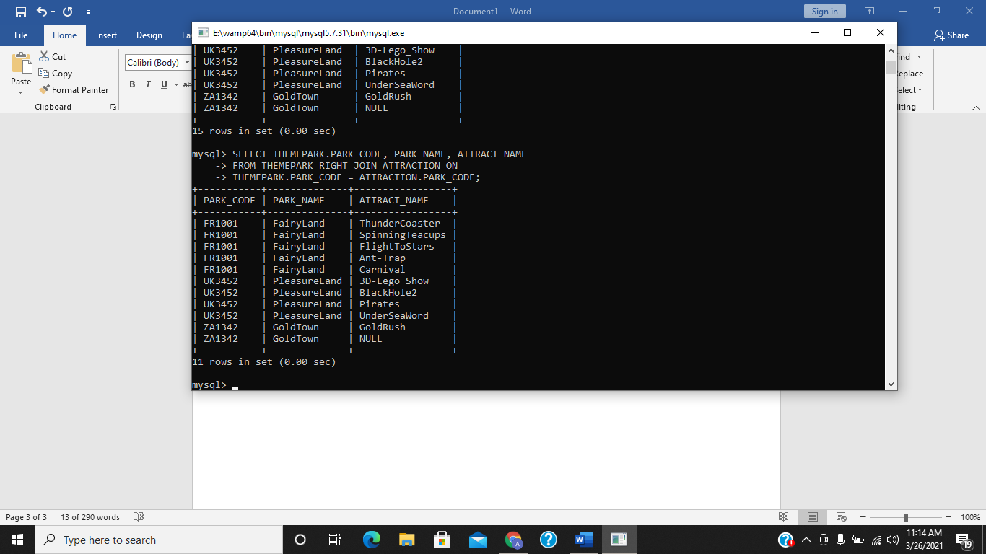

**Exercise:**

**E4.1 Write a query that displays the average hourly rate that has been paid to all employees.**

**Your query should return €7.03.**

select round(avg(hour_rate),2) as "avg(hour_rate)" from hours;

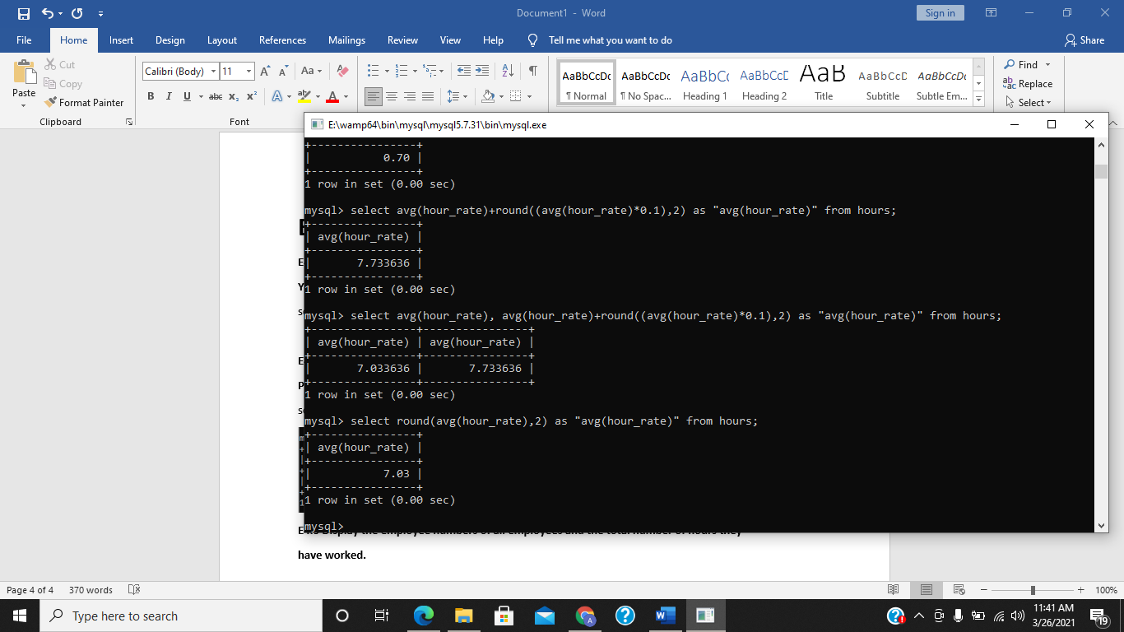

**E4.2 Write a query that displays the average attraction age for all attractions where the**

**PARK_CODE is equal to ‘UK3452’. Your query should return 7.25 years.**

select round(avg(attract_age),2) from attraction where park_code = 'UK3452';

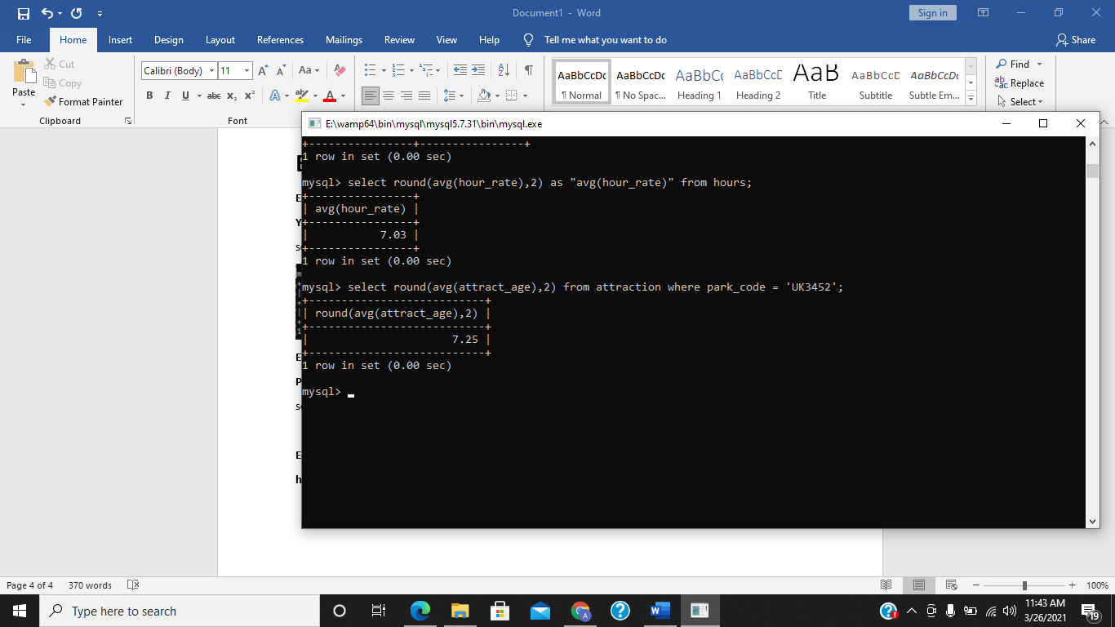

**E4.3 Display the employee numbers of all employees and the total number of hours they**

**have worked.**

select emp_num, sum(hours_per_attract) from hours group by emp_num;

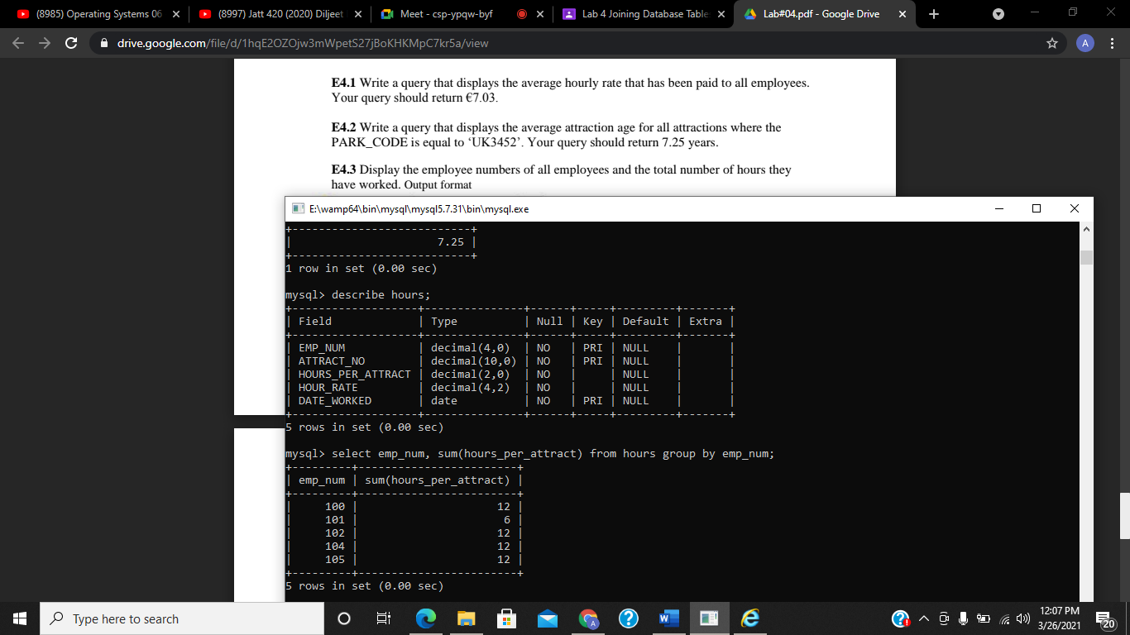

**E4.4 Show the attraction number and the minimum and maximum hourly rate for each attraction.**

select attract_no, min(hour_rate), max(hour_rate) from hours group by attract_no;

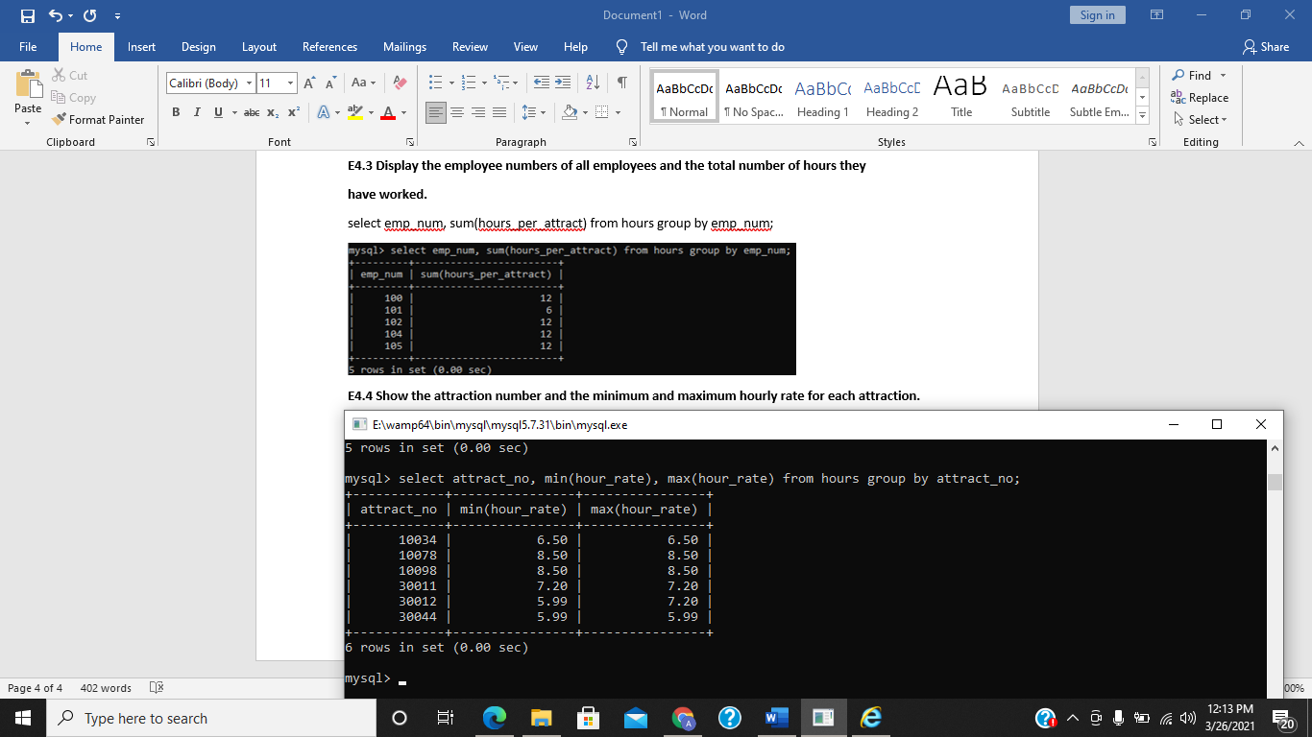

**E4.5 Using the HOURS table, write a query to display the employee number (EMP_NUM), the**

**attraction number (ATTRACT-NO) and the average hours worked per attraction**

**(HOURS_PER_ATTRACT) limiting the result to where the average hours worked per attraction**

**is greater or equal to 5.**

select emp_num, attract_no, avg(hours_per_attract) from hours group by emp_num having avg(hours_per_attract) >= 5;

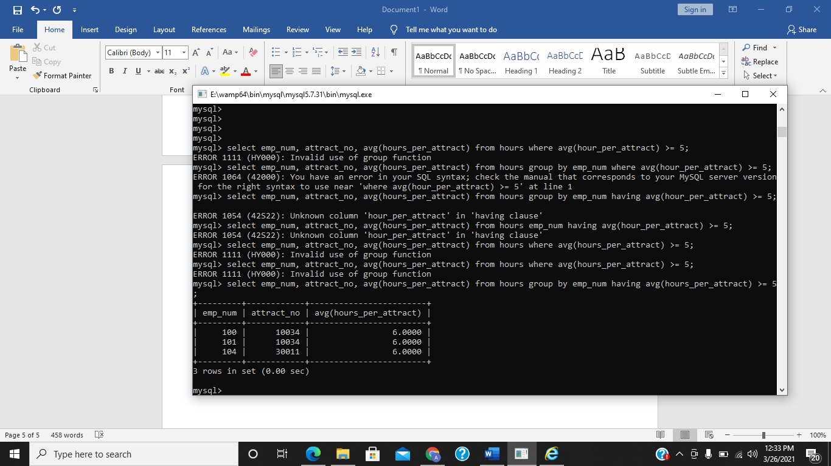

**E 4.6 Write a CROSS JOIN query which selects all rows from the EMPLOYEE and**

**HOURS tables. How many rows were returned?**

select * from employee cross join hours;

77 rows were returned.

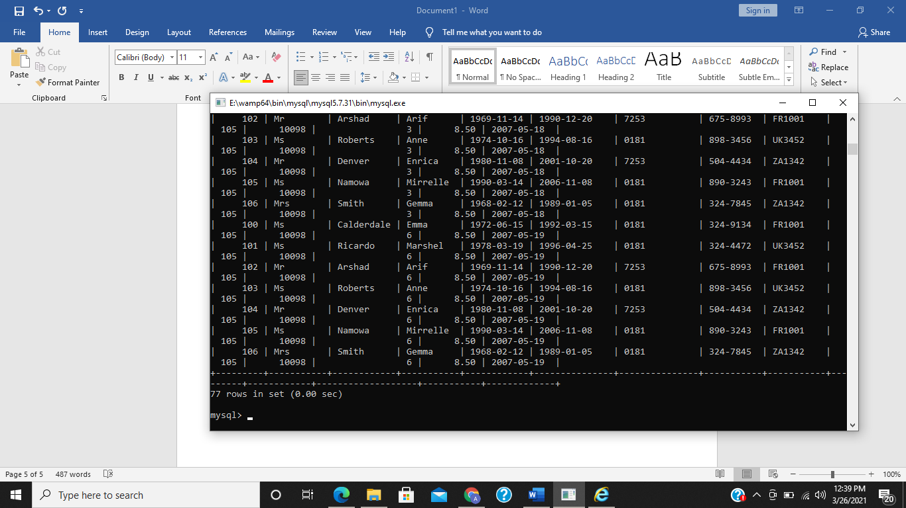

**E.4.7 Write a query that displays the employees first and last name (EMP_FNAME**

**and EMP_LNAME), the attraction number(ATTRACT_NO) and the date worked.**

select emp_lname, emp_fname, attract_no, date_worked from employee natural join hours;

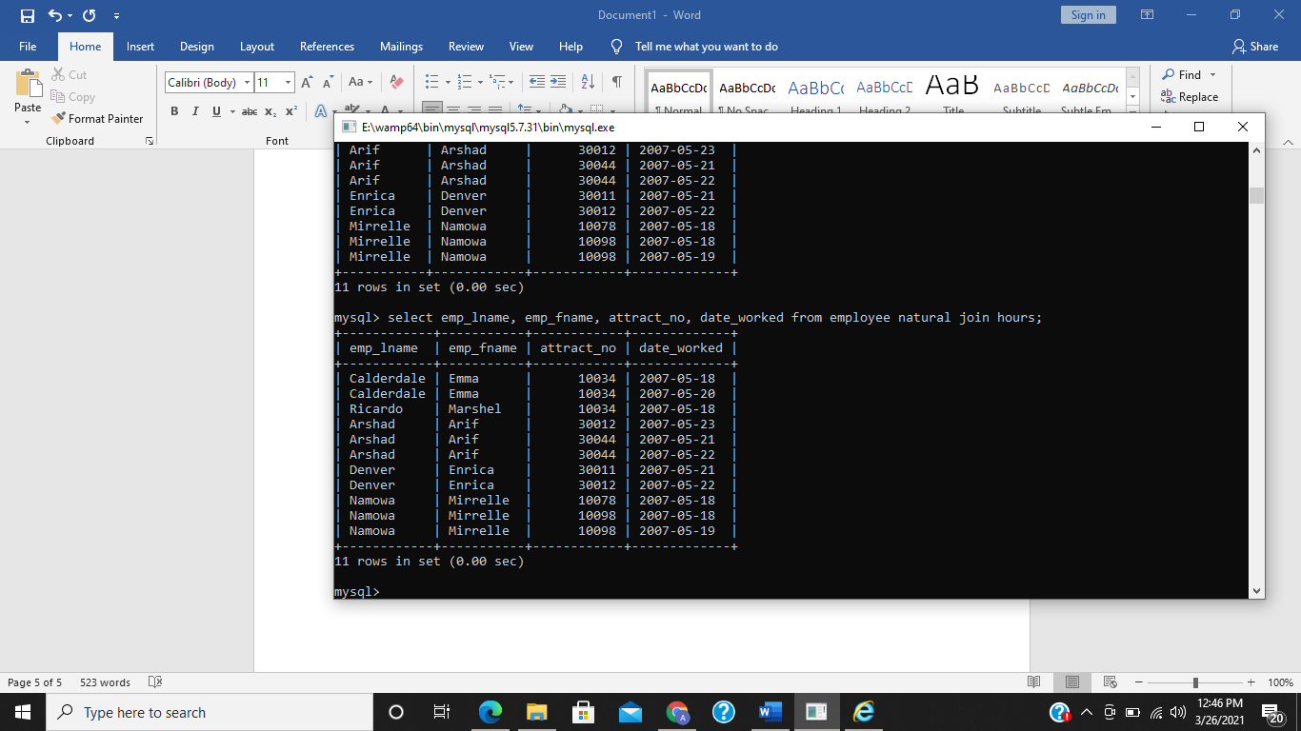

**E4.8 Rewrite the query you wrote in E 4.7 so that the attraction name**

**(ATTRACT_NAME located in the ATTRACTION table) is also displayed. Hint: You**

**will need to join three tables.**

select emp_fname, emp_lname, attract_no, attract_name from employee join hours using (emp_num) join attraction using (attract_no);

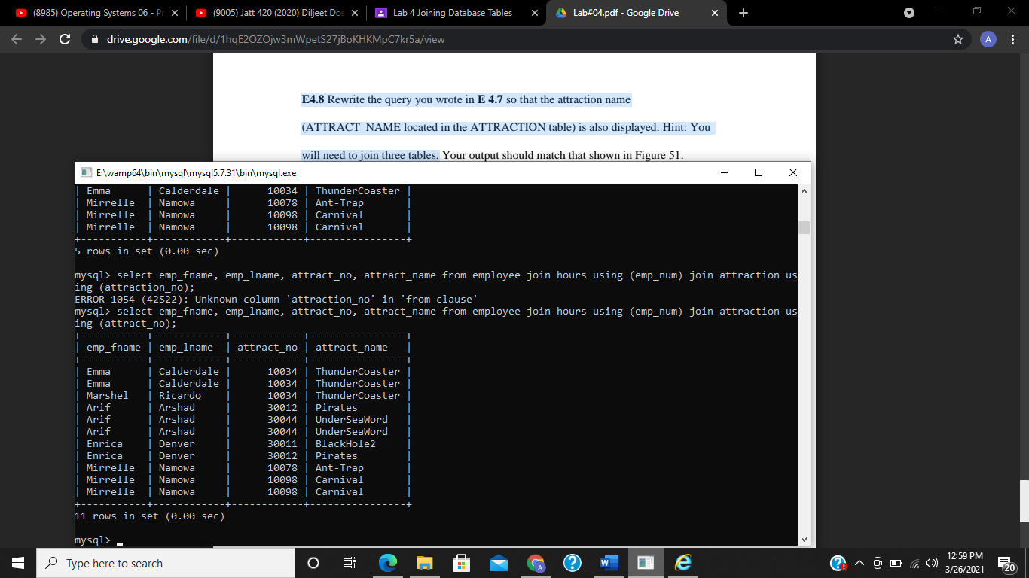

**E4.9 Display the park names and total sales for Theme Parks who are located in the**

**country ‘UK’ or ‘FR’.**

SELECT PARK_NAME, SUM(LINE_PRICE) FROM THEMEPARK JOIN SALES USING (PARK_CODE) JOIN SALES_LINE USING(TRANSACTION_NO) WHERE PARK_CODE LIKE 'UK%' OR PARK_CODE LIKE 'FR%' GROUP BY PARK_NAME;

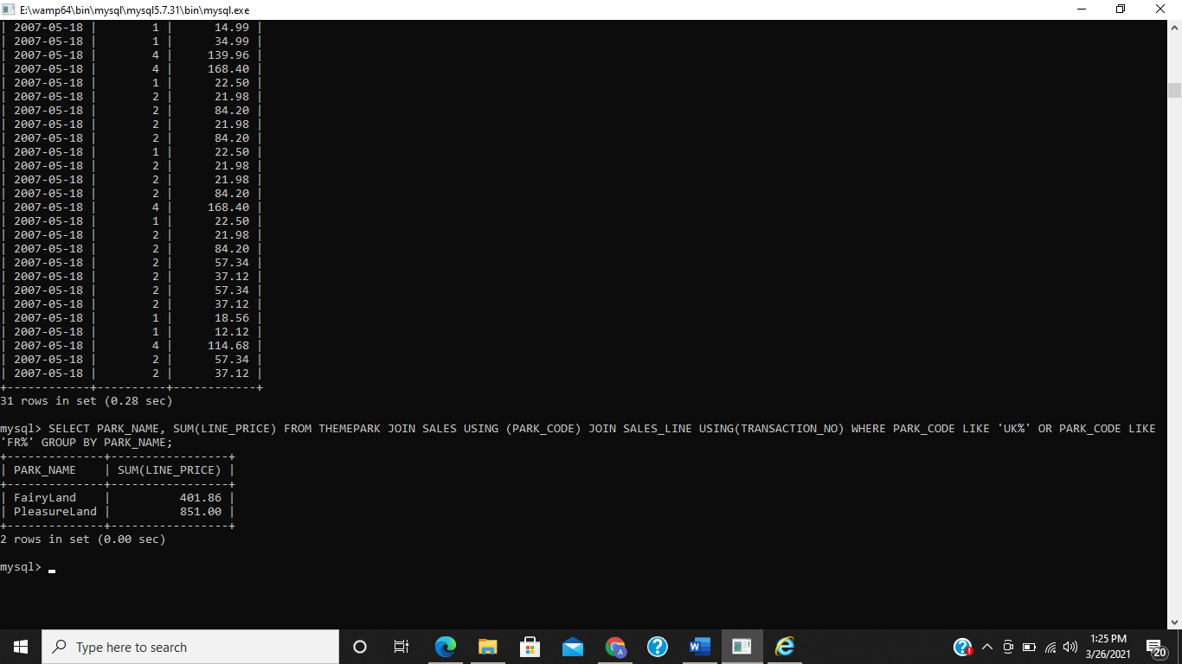

**E4.10 List the sale date, line quantity and line price of all transactions on the 18th May**

**2007. (Hint: Remember the format of MySQL dates is ‘2007-05-18’).**

select sale_date, line_qty, line_price from sales join sales_line using (transaction_no) where sale_date = '2007-05-18';

